Use Case Specification

DMT/RM01/TMP

|  |  |
| --- | --- |
| Project Code | PRJ_IssueTrackingSystem_001 |
| Project Name | I*ssueTrackingSystem* |

|  |  |  |
| --- | --- | --- |
| Prepared/Modified by | Role | Date of Preparation |
| HILOR | Analyst | 27th October00, 2017 |
| Reviewed by | Role | Date of Review |
|  |  |  |
| Approved by | Role | Date of Approval |
|  |  |  |
| Circulation List |  | Version Number of the template:1.1 |
| Version Number | 1.1 |  |

<<Customer>> REVIEW HISTORY

<<Customer comments on the Use case along with the signed off is tracked here>>

|  |  |  |  |  |  |  |
| --- | --- | --- | --- | --- | --- | --- |
| Version | 1.0 |  |  |  |  |  |
| Date | <<Date of Review>> |  |  |  |  |  |
| Reviewed by | << Reviewer Name>> |  |  |  |  |  |
| Reviewed UI Specification doc | << Whether UI Specification doc is reviewed >> |  |  |  |  |  |
| All Open Queries/issues closed | << Whether all the open queries and issues resolved>> |  |  |  |  |  |
| Agreement on Assumptions | <<Whether all the assumptions have been agreed upon by the customer>> |  |  |  |  |  |
| Sign Off | <<Signature>> |  |  |  |  |  |

Disclaimer:

The scope of the project ‘Raise Ticket’ is restricted to the contents of this signed off use case.

TABLE OF CONTENTS

1. Use Case Name: Login to the Leave Management System 5

2. Actor(s) 5

3. Preconditions 5

4. Flow of Events 5

4.1 Basic Flow 5

4.2 Alternative Flows 6

4.2.1 Alternate Flow 1: 6

Name: successful login to LMS on second attempt AND USER Successfully APLLY LEAVES 6

4.2.2 Alternate Flow 2 : 6

Name: Login to the LMS and user Apply for Leaves option and fill correct details second time 6

Exception Flow 1: 7

Name: Exceeded Login Attempts 7

Exception Flow 2: 7

name: Web Server Down 7

Exception Flow 3: 7

Name: Database Connectivity Error 7

Exception Flow 4: 7

Name: Network Connectivity Error 7

Exception Flow 5: 8

Name: user leaves the apply leave form blank and click on submit 8

5. Post Conditions 8

6. Special Requirements 9

Performance 9

Availability 9

User Interface 9

Security 9

7. Extension Points 9

Extension in Alternate Flow 1: 9

8. Business Rules 9

9. Diagrams 10

Use Case Diagram for 10

10. Scenarios 11

Success Scenarios 11

Failure Scenarios 11

11. Issues 11

12. UI Specifications 11

13. Inter System Dependencies 11

14. Integration with an already existing System of the <<Customer>> 12

15. Assumptions 12

1. Use Case Name: Login to the Issue Tracking System

**Use Case ID:**  ITS.USER.RAISETICKET_001

**Brief Description:** This Use Case describes the process by which employees log into the Issue Tracking System

and Raises Ticket

1. Actor(s)
2. Employee(User)
3. Preconditions
4. User has already registered on the Issue Tracking System
5. User has entered the valid URL of Leave Management System and is directed to the home page of ITS
6. User has valid user name and the password
7. Flow of Events

4.1 Basic Flow

Name: Successful login to the Issue Tracking System and user successfully raises ticket.

1. User clicks on the **Login** link on the Leave Management System home page.
2. The system displays **Login** page
3. User enters **Username**
4. User enters **Password**
5. User clicks on the **Login** button
6. The system validates **Username** & **Password**
7. The system navigates user to the page having few options.
8. The user clicks on **Raise New Ticket**.
9. A form is displayed.
10. User meed to enter appropriate details.
11. Click on **Submit**  button.

Ticket is Raised successfully.

1. A unique ticket number is should be generated once the ticket has been raised successfully by the employee.
2. An autogenerated notification email is sent to employee’s manager to seek approval on ticket raised by the employee to process the ticket.
   1. Alternative Flows
      1. Alternate Flow 1:

Name: successful login to ITS on second attempt AND USER Successfully Raises Ticket

1. User clicks on the **Login** link on the Issue Tracking System home page
2. The system displays Login page
3. User enters Username
4. User enters Password
5. User clicks on the Login button
6. The system validates Username & Password
7. The system validation fails due to invalid user credentials
8. Displays an error message “**The system could not log you in. Please make sure your username and password are correct.**”
9. The system propmts the user to re-enter the username and password
10. The step 3 of Basic flow is followed.

* + 1. Alternate Flow 2 :

Name: Login to the ITS and user RAise New Ticket option and fill correct details second time

1. User clicks on the **Login** link on the Issue Tracking System home page.
2. The system displays **Login** page
3. User enters **Username**
4. User enters **Password**
5. User clicks on the **Login** button
6. The system validates **Username** & **Password**
7. User clicks on **Raise New Ticket.**
8. The system navigates user to the **Raise New Ticket** form.
9. User forgets to enter one of the mandatory fields.
10. User Clicks the Submit Button
11. System Prompts the user to enter all the required fields.
12. User enters the mandatory fields.
13. User clicks on submit button.
14. System prompts the user and provides him/her with the unique ticket number.
    * 1. Alternate Flow 3 :

Name: Login to the ITS and user RAise New Ticket option and fill correct details third time

1. User clicks on the **Login** link on the Issue Tracking System home page.
2. The system displays **Login** page
3. User enters **Username**
4. User enters **Password**
5. User clicks on the **Login** button
6. The system validates **Username** & **Password**
7. User clicks on **Raise New Ticket.**
8. The system navigates user to the **Raise New Ticket** form.
9. User enters details of all the mandatory fields.
10. User attaches a file with extension other than **.jpg**, **.gif** and **.doc.**
11. User clicks on submit button.
12. The system does not accept the attachment
13. User removes it by clicking on **Clear Attachments**.
14. User attaches correct file.
15. User clicks on submit button.
16. System prompts the user and provides him/her with the unique ticket number.
    * 1. Alternate Flow 4 :

Name: Exceeded extention number length

1. User clicks on the **Login** link on the Leave Management System home page.
2. The system displays **Login** page
3. User enters **Username**
4. User enters **Password**
5. User clicks on the **Login** button
6. The system validates **Username** & **Password**
7. The system navigates user to the page having few options.
8. The user clicks on **Raise New Ticket**.
9. A form is displayed.
10. User need to enter appropriate details.
11. User enters extention number more then 4 digits.
12. System promts an error message.
13. User enters valid number.
14. Click on **Submit**  button.

Ticket is Raised successfully with a unique ticket number.

* + 1. Alternate Flow 5 :

Name: Exceeded mobile number length

1.User clicks on the **Login** link on the Leave Management System home page.

2.The system displays **Login** page

3.User enters **Username**

4.User enters **Password**

5.User clicks on the **Login** button

6.The system validates **Username** & **Password**

7.The system navigates user to the page having few options.

8.The user clicks on **Raise New Ticket**.

9.A form is displayed.

10.User need to enter appropriate details.

11.User enters mobile number more then 10 digits.

12.System promts an error message.

13.User enters valid number.

14.Click on **Submit**  button.

Ticket is Raised successfully with a unique ticket number.

* + 1. Alternate Flow 6 :

Name: current location

* + - 1. User clicks on the **Login** link on the Leave Management System home page.

2.The system displays **Login** page

3.User enters **Username**

4.User enters **Password**

5.User clicks on the **Login** button

6.The system validates **Username** & **Password**

7.The system navigates user to the page having few options.

8.The user clicks on **Raise New Ticket**.

9.A form is displayed.

10.User need to enter appropriate details.

11.User enters current location other than company addresses..

1. System promts an error message.
2. User enters valid address.
3. Click on **Submit**  button.

Ticket is Raised successfully with a unique ticket number.

* + 1. Alternate Flow 7 :

Name: domain name

* + - 1. User clicks on the **Login** link on the Leave Management System home page.

2.The system displays **Login** page

3.User enters **Username**

4.User enters **Password**

5.User clicks on the **Login** button

6.The system validates **Username** & **Password**

7.The system navigates user to the page having few options.

8.The user clicks on **Raise New Ticket**.

9.A form is displayed.

10.User need to enter appropriate details.

11. user enters CC filed with email id not having domain as **igate.com.**

1. System promts an error message.
2. User enters valid domain name.
3. Click on **Submit**  button.

Ticket is Raised successfully with a unique ticket number.

Exception Flow 1:

Name: Exceeded Login Attempts

1. User clicks on the **Login** link on the Leave Management System home page
2. The system displays **Login** page
3. User enters **Username**
4. User enters **Password**
5. User clicks on the **Login** button
6. The system validates **Username** & **Password** for 5th time.
7. The system validation fails due to invalid user credentials and no more login attempts remaining
8. The system temporarily blocks the user account
9. The system informs the user that his/her account has been temporarily blocked.

Exception Flow 2:

name: Web Server Down

1. User clicks on the **Login** link on the Leave Management System home page
2. The system displays an error message regarding web server unavailability problem

Exception Flow 3:

Name: Database Connectivity Error

1. User clicks on the **Login** link on the Leave Management System home page.
2. The system displays **Login** page.
3. User enters **Username**
4. User enters **Password**
5. User clicks on the **Login** button
6. The system validates **Username** & **Password**
7. The system displays an error message regarding database connectivity problem.

Exception Flow 4:

Name: Network Connectivity Error

1. User clicks on the **Login** link on the Leave Management System home page.
2. The system displays **Login** page.
3. User enters **Username**
4. User enters **Password**
5. User clicks on the **Login** button
6. The system validates **Username** & **Password**
7. The system displays an error message regarding network connectivity problem.

Exception Flow 5:

Name: user leaves the apply leave form blank and click on submit

1. User clicks on the **Login** link on the Leave Management System home page.
2. The system displays **Login** page.
3. User enters **Username**
4. User enters **Password**
5. User clicks on the **Login** button
6. The system validates **Username** & **Password**
7. Apply for Leaves page is displayed.
8. User keeps the form blank and click on submit button.
9. System prompts the user to enter the Required details.
10. Post Conditions

| Flow Name | Post Condition |
| --- | --- |
| successful login to ITS on second attempt AND USER Successfully RAISES TICKET | User will be logged in to the ITS successfully and system should navigate user to the Raise New Ticket form page and user raise ticket successfully. |
| successful login to ITS on second attempt AND USER Successfully RAISE TICKET | User will be logged in to the ITS successfully and system should navigate user to the Raise New Ticket form page and user raise ticket successfully. |
| Exceeded Login Attempts | The system should suspend the user account and should inform the user that his/her account has been blocked. |
| Web Server Down | The system should display an error message to the user regarding web server unavailability problem. |
| Database Connectivity Error | The system should display an error message to the user regarding the database connectivity problem. |
| Network Connectivity Error | The system should display an error message to the user regarding the network connectivity problem. |
| User leaves the apply leave form blank and click on submit | The System Prompts the user to enter all the required fields. |

1. Special Requirements

Performance

1. The click on Ok button of login shall display the home page within 5 seconds of user request

User Interface

* 1. The Labels of the form shall be bold
  2. All the by drop down menus should have a default option
  3. Mandatory fiels should be marked by astricks
  4. The logout and back button should be available on every page of the application

Security

1. Remember my credential option should save username and password in html cookies.
2. Extension Points

Extension in Alternate Flow 1:

In step 7, if the customer has entered wrong user credentials :

1. The system prompts the user to re-enter the credentials

2. User enters the username and password

3. The system takes user to the **Step 3** of **Basic Flow**

1. Business Rules

| Business Rule Name | Business Rule Description | System action (if BR fails) |
| --- | --- | --- |
| BR01 | User must be valid | User is prompted to re-enter the login credentials |
| BR02 | User can view his application status only by entering valid Application_Id | Displays error message “Invalid Application_Id” |

1. Diagrams

Use Case Diagram for

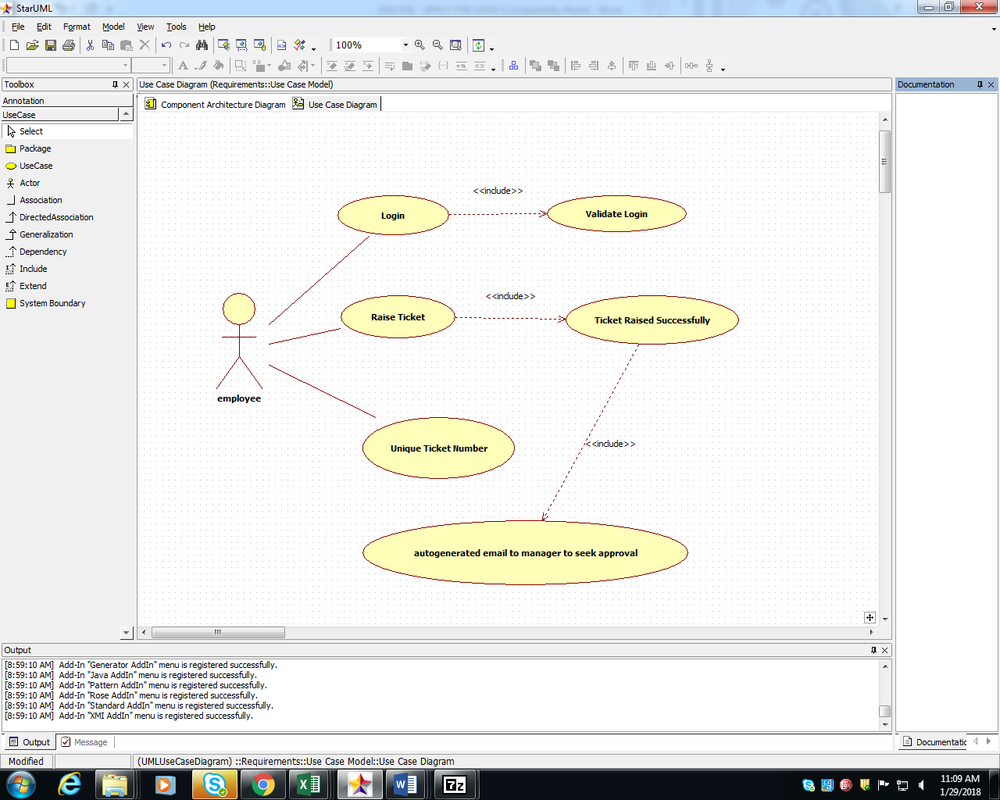

1. Scenarios

Success Scenarios

* Successful login to ITS on second attempt AND USER Successfully RAISE TICKET
* Failure Scenarios
* Exceeded Login Attempts
* Web Server Down
* Database Connectivity Error
* Network Connectivity Error
* User leaves the apply leave form blank and click on submit

1. Issues

* What is the maximum size of username and password that a user can have ?
* What if the user is blocked after invalid login attempts for three times ?

1. UI Specifications

<< Provide a link to the UI specification document of the Use case. Please don’t embed the document here>>

1. Inter System Dependencies

**Module: ‘Raise New Ticket**’ gets impacted due to :

Use case name: Alternate Flow 1

**Impact**: If the user tries to raise ticket without login, he should be denied to do so.

1. Integration with an already existing System of the <<Customer>>

<< This is especially applicable if the project at hand is an enhancement to an existing system.>>

1. Assumptions

<< List down all the assumptions considered by this use case>>

REVISION HISTORY OF THE WORK PRODUCT

<to be maintained by projects>

|  |  |  |  |  |  |
| --- | --- | --- | --- | --- | --- |
| # | Date | Version # | Section Changed | Details of changes made | Approved By |
| 1 |  |  |  |  |  |
| 2 |  |  |  |  |  |